A000-Afr-Namibia-Biface-Paleolithic-200,000 BP

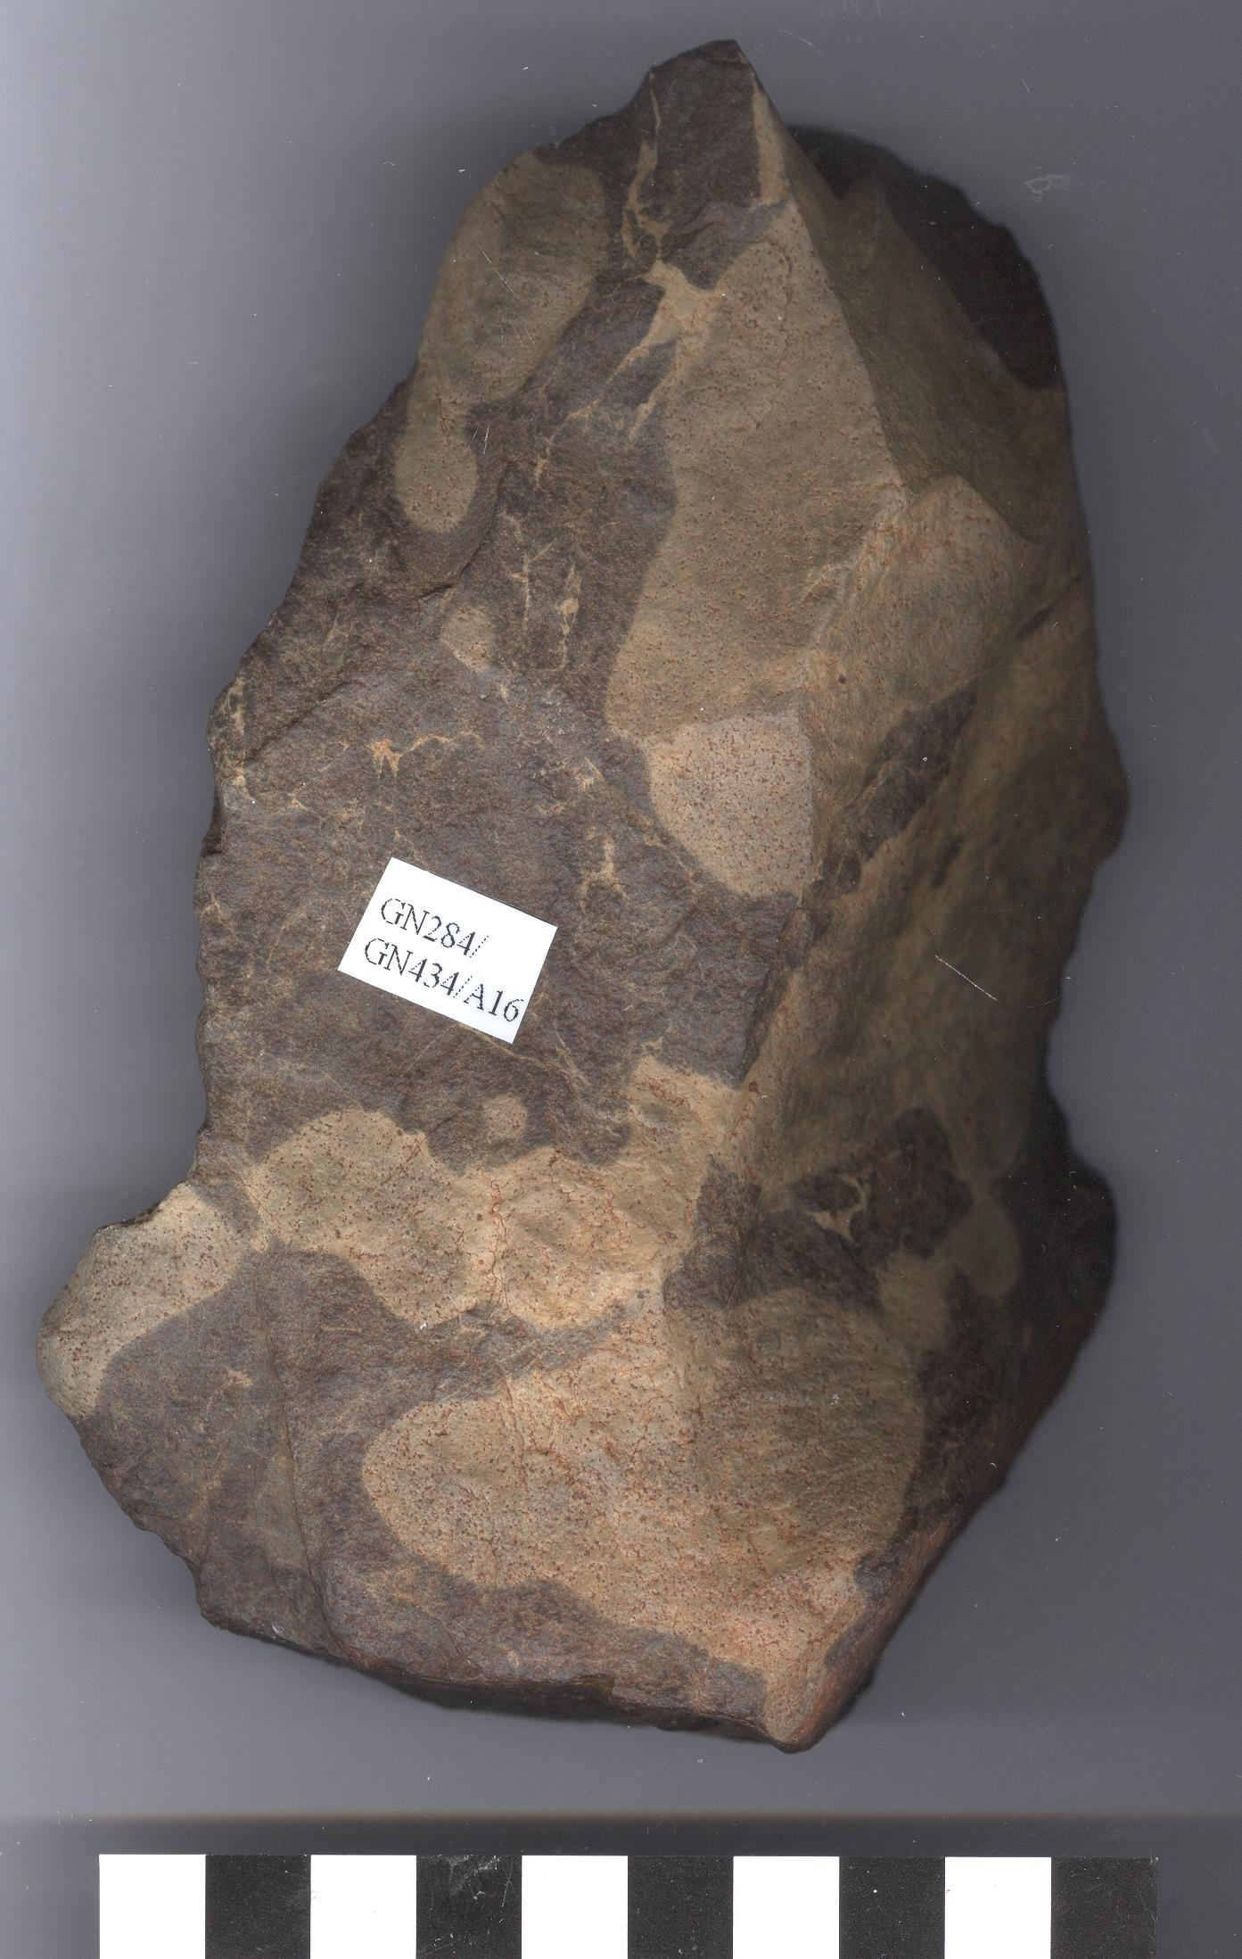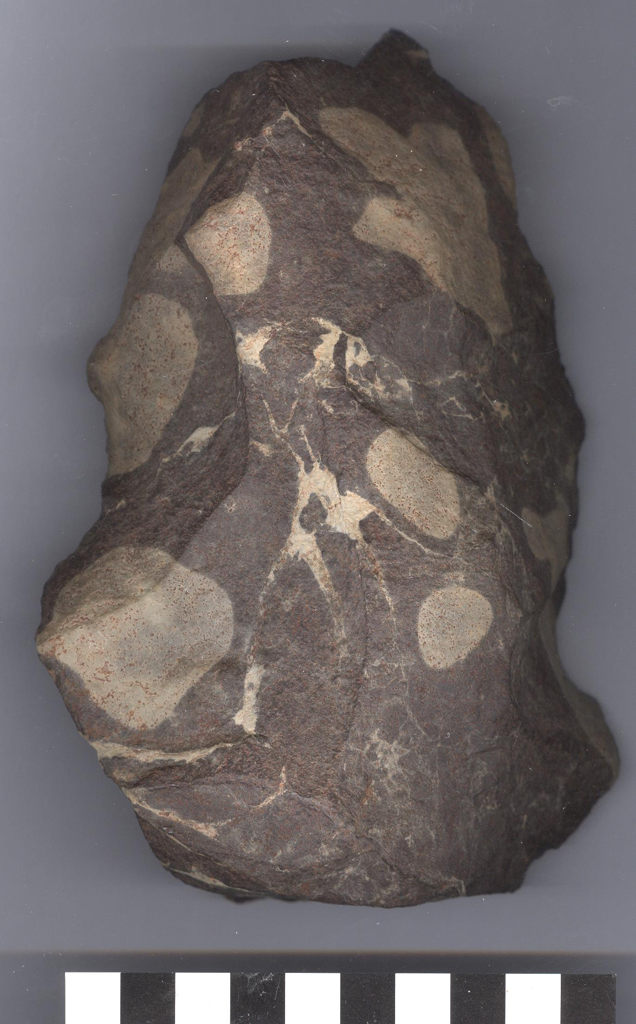

Fig. 1-2. Paleolithic Biface of *Homo erectus*, 200,000 BP, Ugab River, Namibia, dorsal and ventral surfaces.

Formal Label: Paleolithic Biface of *Homo erectus*, 200,000 BP, Ugab River, Namibia.

**Display Description:**

Found on a surface survey by Susan Murcott, August 2008, on the gravel plains of the Namib Platform within the larger Tumas Basin (Ward 1987; Wilkinson 1991; Miller 2008). The bedrock includes schists and marbles of the Proterozoic Damara Sequence. This unusual side-notched biface axe was hafted as a halberd for butchering meat and was made by early Hominins, possibly Homo Erectus (even though known Homo Erectus sites are east of Namibia). 200,000 years ago marked a wetter climatic period when sub-Saharan savannahs could support megafauna.

Accession Number: A16.

LC Classification: GN865.S25

Date or Time Horizon: 200,000 BP

Geographical Area: Ugab River, Namibia

**Map, GPS coordinates:** -21.01033 14.70830;40° 26' 46" N 79° 58' 56" W

 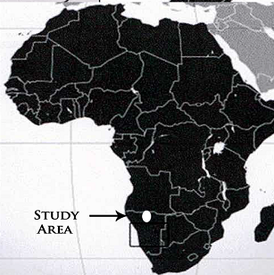

Fig. 3. Map indicating the location of the surface scatter area investigated and study area placement map in Africa.

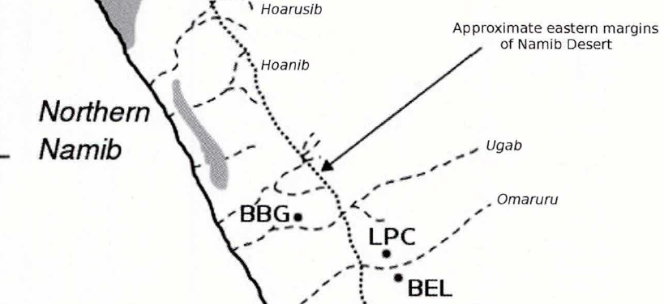

*Northern Namib: locations of archaeological sites. BBC, Brandberg; LPC, Leopard Cave; BEL, Big Elephant*

*Rockshelter; ETS.*

Cultural Affiliation: *Homo erectus*

Medium: **silicified sandstone**

Dimensions: H 6.03 in (153.06 mm); W 4.61 in (117.10 mm).

Weight:

Condition: original.

Provenance: Susan Murcott, field survey, 2008.

**Discussion:**

While surface deposits cannot establish a stratigraphically controlled chronology, they do permit insights into larger spatial scales of behavioral organization. We were able to survey Early Stone Age (ESA) and Middle Stone Age (MSA) lithic artefactual surface scatter on Central Namib Desert gravels north of Brandberg Mountain and the Ugab River, a region that was desertified from the Cenozoic throughout the Pleistocene with some pluvial episodes. Based on characteristics of the lithic assemblage, it appears that human groups over tens of thousands of years on the Central Namib Desert gravels employed exotic and local stone resources in the ESA and predominantly local stone resources in the MSA in their focused hunting activities adjacent to the ephemeral Ugab drainage.

Our data suggest that *Homo erectus* in the ESA was able to exploit megafauna such as *Elephas recki* (H 14 ft, 4.27 m) between3.5 and .5 Ma. for which it manufactured large butchering tools, like the example shown here. This hafted, silicified sandstone butchering tool was selected because of its cognitively sophisticated shape, expert lithic technology and aesthetically pleasing silicified sandstone matrix. The tip had been broken off in the process of butchering, but the full story remains hidden within the rock

The MSA tool kit that we surveyed in lithic scatter, however, was comprised mainly of local stone and the tools were much more modest in size containing backed knives and scrapers averaging 3-5 in in length.

**References:**

Deacon, Janet. 1999. *Human beginnings in South Africa: uncovering the secrets of the Stone Age*. Walnut Creek, Calif.; London: AltaMira.

Hardaker, Terry R. 2011. *New approaches to the study of surface Paleolithic artefacts: a pilot project at Zebra river, Western Namibia*. BAR. International series. 2270. Oxford: Archaeopress.

Ward 1987; Wilkinson 1991; Miller 2008

Ward 1987; Wilkinson 1991; Miller 2008

Todd, N. E. 2001. African Elephas recki: Time, space and taxonomy. In: Cavarretta, G., P. Gioia, M. Mussi, and M. R. Palombo. The World of Elephants, Proceedings of the 1st International Congress. Consiglio Nazionale delle Ricerche. Rome, Italy